5pcs Garden Hose Connector Set Spray Gun Water Sprayer And Pipe Fittings

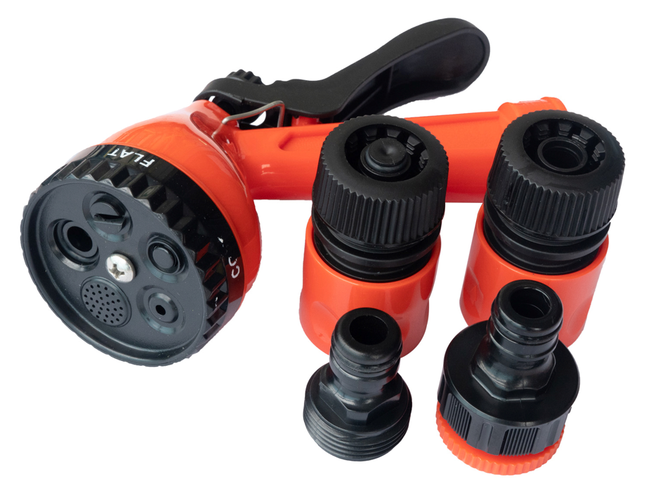

MULTIFUNCTIONAL: This Garden Spray gun has 5 multi-functional watering settings,Prefect for patio, lawn, garden watering and car wash etc.

- Included in the set:-

- 1pc x 5 dial function Spray gun,
- 1pc x 3/4"~1/2"female tap adaptor,
- 1pc 3/4"male adaptor,
- 1pc Hose quick connector
- 1pc Hose quick connector with stop
- Part number: LMS504008
- Barcode number:8400800041135

